- Archive Data Pipeline (✅complete)
Re-designed the archive process to capture audit this
  - Make ETL historical data much more efficient, as it avoids reloading the same files
  - Provides upsert ability into the datalake (to the archive database)
  - This along with other audit tables can be used for monitoring
--LOAD HISTORY
%%sql

select * from
monitoring.cfg_archive_file_load
where
target_object <>'archived.archived_audit'
and
status <>'FAILED'
order by last_updated_at DESC

--DAILY LOAD SUMMARY
%%sql

with cte as (
select max(CAST(x.started_at as DATE)) max_date
from monitoring.cfg_archive_file_load x
)
select CAST(a.started_at as DATE) load_date
,max(a.started_at) max_load_datenoooo

,target_object,status
, MIN(export_date) min_export_date
,max(export_date) max_export_date
, count(*) file_count
from
monitoring.cfg_archive_file_load a
CROSS join cte x
where x.max_date = CAST(a.started_at as DATE)
and
target_object <>'archived.archived_audit'
group by CAST(a.started_at as DATE),target_object,status
order by 2 desc, status

- ETL: Audit tables created (✅complete)
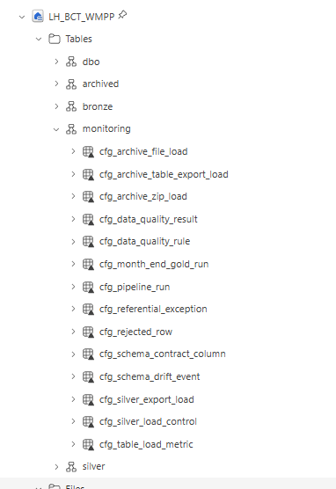

- NEC Portal Access (🛩️ inflght)
@Hamant K Jakhu raised a request this week to gain access to the NEC portal. I have sent a following up reminder. Still awaiting NEC response
- Create the Silver layer tables (✅complete)
  - Created: challenges with the data faced are as follows
    - Here is the Original Schema definition provided  Data Dictionary (April 26).csv
    - This was out of date. Data types were incorrect, the fields were out of date, some fields were missing or the names were changed, also some tables missed out entirely from the definition
    - I have provided a link to the Latest schema definition that’s used by the ETL.  ETL Docs
    - I have updated the schema definition file accordingly with all the issues that I have found so far, but will make ongoing additions and updates as needed. I still might have undiscovered tables that need adding to the spec
  - Based on the updated schema definition I have created the schema for the silver layer but yet to get the process piped in
  - 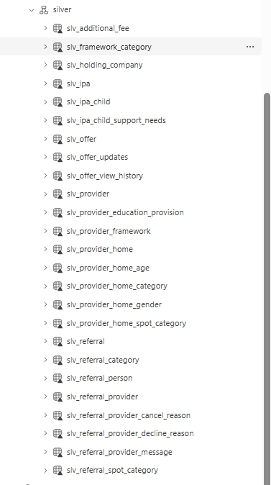
  - I have provided a link to my issues while creating the ETL solution  Issue Log

- Pipe up the silver layer tables to run daily (⚠️not started) (90% outstanding)
  - I have an idea of the process but not yet started this piece
- Add the remaining missing KPIs to the reports (❌ not started)
- Add tooltips to the dashboard KPIs to clearly show which functional requirement they relate to
  - Add dashboard descriptions to help new users understand and navigate the reports
  - 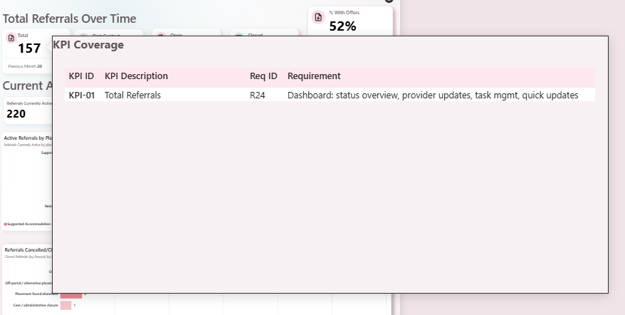

Actions for Next Week
- (90% outstanding) Automate the ETL process up to the Silver layer
- Add the remaining missing KPIs to the reports

Backlog Items
- Redesign the dashboard
- Create the Gold layer
- Implement audit tables within the data lake to monitor loads and provide greater control over the ETL process (including Delta/Batch processing where appropriate)
- Apply business rules to the Silver layer

